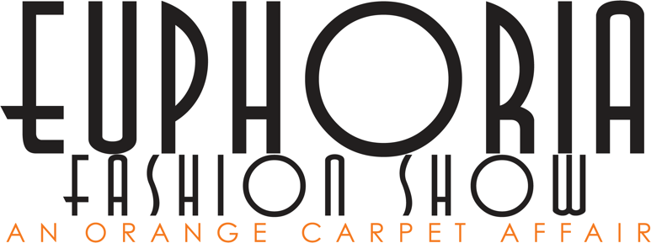
MODEL CONTRACT AND EXPECTATIONS 2020
MODEL CONTRACT. This Model Contract is made effective as of ___January 13, 2020___, by and between the Euphoria Fashion Show Students and the MODEL.

PURPOSE OF CONTRACT. This contract is for the engagement of the MODEL as a participant in the Euphoria Fashion Show and is a volunteer for this event. CLIENT will engage the MODEL as a photographic model for the use of designer portfolios, Oklahoma State University, and the Department of Design Housing and Merchandising marketing purposes. This includes all social media outlets.

DESCRIPTION OF SERVICES. Being of ____January 13th, 2020____, the MODEL will provide the following services:
- Model for the Euphoria Fashion Show
- Attend all mandatory events including 3 of 4 model workshops, hair/make-up appointments, and all other events specified by the producers for the Euphoria Fashion Show (Jill Cope and Ombree George)
- Responsible for attending fittings scheduled by the student designers
PAYMENT FOR SERVICES. The MODEL understands that this is a non-paying volunteer job. There will be no compensation for the MODELS time they are offering. MODEL can receive community service hours for their time the day of the show if previously requested by the MODEL. This request must be made in advance from the MODEL to the CLIENT.

TERM/TERMINATION. The MODEL will commence work under this contract as of ___January 13, 2020____, and will continue to work until ___April 30 , 2020___, unless the MODEL makes a good-faith determination __two weeks _prior to the show April 17th, 2020. The CLIENT may terminate this contract upon __ __failure to meet any and all of the terms listed above______. CLIENT may terminate this contract at any time if CLIENT is dissatisfied with the MODELS performance or for other good cause.

INJURIES/LIABILITY. MODEL acknowledges MODELS obligation to obtain appropriate insurance coverage for the benefit of MODEL. MODEL waives any rights to recovery from CLIENT for any injuries that the MODEL may sustain while performing services under this Contract. CLIENT will not be held responsible for the MODEL’s injuries during the time that this contract is active, and MODEL understands this. Oklahoma State University will not be held responsible for any injuries that may be sustained by the MODEL.

WARDROBE. CLIENT will provide all garments to MODEL for the day of the Euphoria Fashion Show. The garments provided by the CLIENT will remain in possession of the CLIENT throughout the entirety of the rehearsals, show, and after the show. The MODEL is required to bring their own undergarments including nude spanks and sticky bras. These will be purchased by the MODEL and will remain in the possession of the MODEL.

INDEMNIFICATION. MODEL agrees and understands that any items owned and brought on their behalf is the MODEL’s responsibility and can not hold the CLIENT responsible for lost, damaged, or missing property. CLIENT will not provide compensation for these items.

MODEL EXPECTATIONS
WORKING WITH THE MAKE-UP AND HAIR STYLISTS
This is a time to support the designers and their visions for how your overall look should be. As a model you are the canvas for the designer, and it is not your place to argue about your look. Do not come with any assumption of what you will look like because it is up to the designer to choose. *All models are required to bring their own foundation.

BASIC ETIQUETTE OF BEING A MODEL
- Be on Time - show up when you are expected. It is very rude to waste other people's time when you are late. If you are late, communicate to your designer or stylist what the situation is
- Do not be Flaky - this means canceling at the very last minute (hours or minutes before expected)
- Time Manage - making sure you are managing your time to benefit yourself, designer, and stylists
- Take Care of Yourself - this means getting rest, staying hydrated, eating well, and relieving stress
- Take Care of Your Appearance - having good hygiene, cleaning your nails, hair, and keeping yourself well maintained
- Communicate - this is the key to success in everything. Please make sure to communicate with designers, stylists, and model director if you have questions or concerns.
- Be Respectful - remember that you are supporting the designers and they have worked very hard on the clothes you will be wearing. You are not only representing yourself but the designers, college, and Oklahoma State
***Remember to be professional in everything you do. This means that being a model is a privilege and you are expected to follow all expectations and requirements. If you are not behaving accordingly then you will be pulled from the show and will not be modeling. If the garment you are expected to wear gets pulled, then you may not be walking in the show. Keep in mind that you are representing many people and not only yourself.

APPLICABLE LAW. This Contract shall be governed by the laws of the State of Oklahoma.

SIGNATORIES. This Agreement shall be signed on behalf of CLIENT by DIANE LIMBAUGH, JILL COPE, or OMBREE GEORGE and shall be signed by MODEL by ____February 7, 2020______ and effective as of the date first written above. BOTH parties understand that this Contract will be signed electronically and hold the same weight as a physical signature.

PARTY CONTRACTING SERVICES. Euphoria Fashion Show

By: __________________________________ (signed upon Contract approval)
DIANE LIMBAUGH, JILL COPE, OR OMBREE GEORGE

By: ___________________________________ (model sign name here)

_______________________________________(model print name here)
MODEL

*This form can be turned in via email to OSUEuphoria@gmail.com or can be printed and brought to a model workshop or the DHM office 430 in Human Sciences.

